1 Objective and Summary

* 1. Zielsetzung 1.1 Objectives

• elimination of some firmware error  
• Replace bridge amplifier ZMD against SX8723c  
• equidistant measurement of the measured values

* 1. Zusammenfassung Summary

• New bridge amplifier (SX8723c) with higher resolution, lower signal-to-noise ratio and higher gain  
• Isochronous timestamp (FFT possible)  
• Battery charge level management with closer and shut down the system after fall below the critical voltage  
• Temperature is often read  
• Elimination of the watchdog resets the standby

1. Übersicht Arbeitspakete
   1. Spike Flex

|  |  |  |
| --- | --- | --- |
| **Modul** | **description** | **done?** |
| SX8723c | functions for communication with the bridge amplifier (initialization, register read / write) | ✓ |
| SX8723c | Auto Offset Funktion | ✓ |
| SX8723c | Sleep Mode | ✓ |
| Software TWI | Software on SX8723c and speed increase TWI adjustment to 400 kHz | ✓ |
| EEPROM | EEPROM structure of the EEPROM adapt to SX8723c | ✓ |
| AT86RF231 | Customize AT86RF231 payload on the new bridge amplifier | ✓ |
| Timer | Timer readout rate of the overall system change if possible, otherwise less at 1600 Hz | ✓ |
| Main Routine | Check Main routine operation of the entire program and adapt | ✓ |
| charging status | Customize charging status on new input signal | ✓ |
| Switching off the bridges | Switching off the bridges Customize new output signal | ✓ |
| Communication with table-unit | Check that all commands work and whether they need to be adapted | ✓ |
| Watchdog | In sleep mode, the microcontroller is performed every new 8s, this error should be fixed | ✓ |
| EEPROM | EEPROM content is not translated | ✓ |
| AVR Studio | integration of the project in AVR Studio 5 | ✓ |
| DS620 | resolution of the temperature sensor to 12 bits | ✓ |
| DS620 | Change DS620 Troubleshooting: TWI speed of the temperature sensor is far too slow ◊ increase to 400 kHz | ✓ |
| DS620 | Troubleshooting: temperature sensor provides no negative | ✓ |
| Timing Test | the temporal sequence of the system verify | ✓ |
| Funktionstest | Function test function of the system verify | ✓ |
| Power Management | Power management system shutdown at defined below a threshold | ✓ |

Stand 18.07.2013

* 1. Spike table device

|  |  |  |
| --- | --- | --- |
| **Modul** | **description** | **done?** |
| USB customize | Customize USB Edition to new values of the bridge amplifier | ✓ |
| time stamp | Adjust time stamp generation of the time stamp on new readout rate | ✓ |
| Communication with Flex | Check that all commands work and whether they need to be adapted | ✓ |
| Timing Test | Timing test the temporal sequence of the system verify | 🗶 |
| Funktionstest | Function test function of the system verify | 🗶 |

Stand 18.07.2013

1. SX8723c
   1. Zuordnung der Brücken(Assignment of bridges)

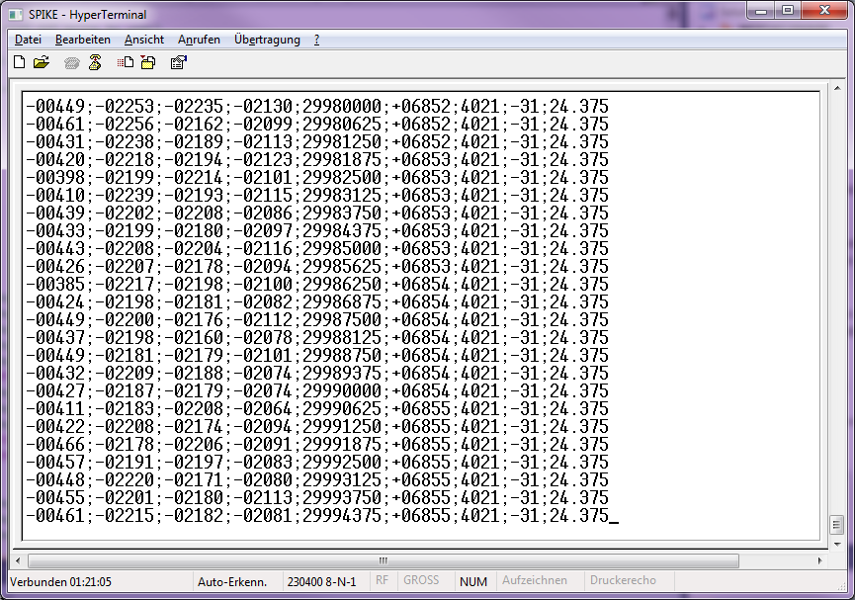

**SG_3**

**SG_1**

**SG_4**

**SG_2**

Every 625ms ..see the difference in last 3-4 digits

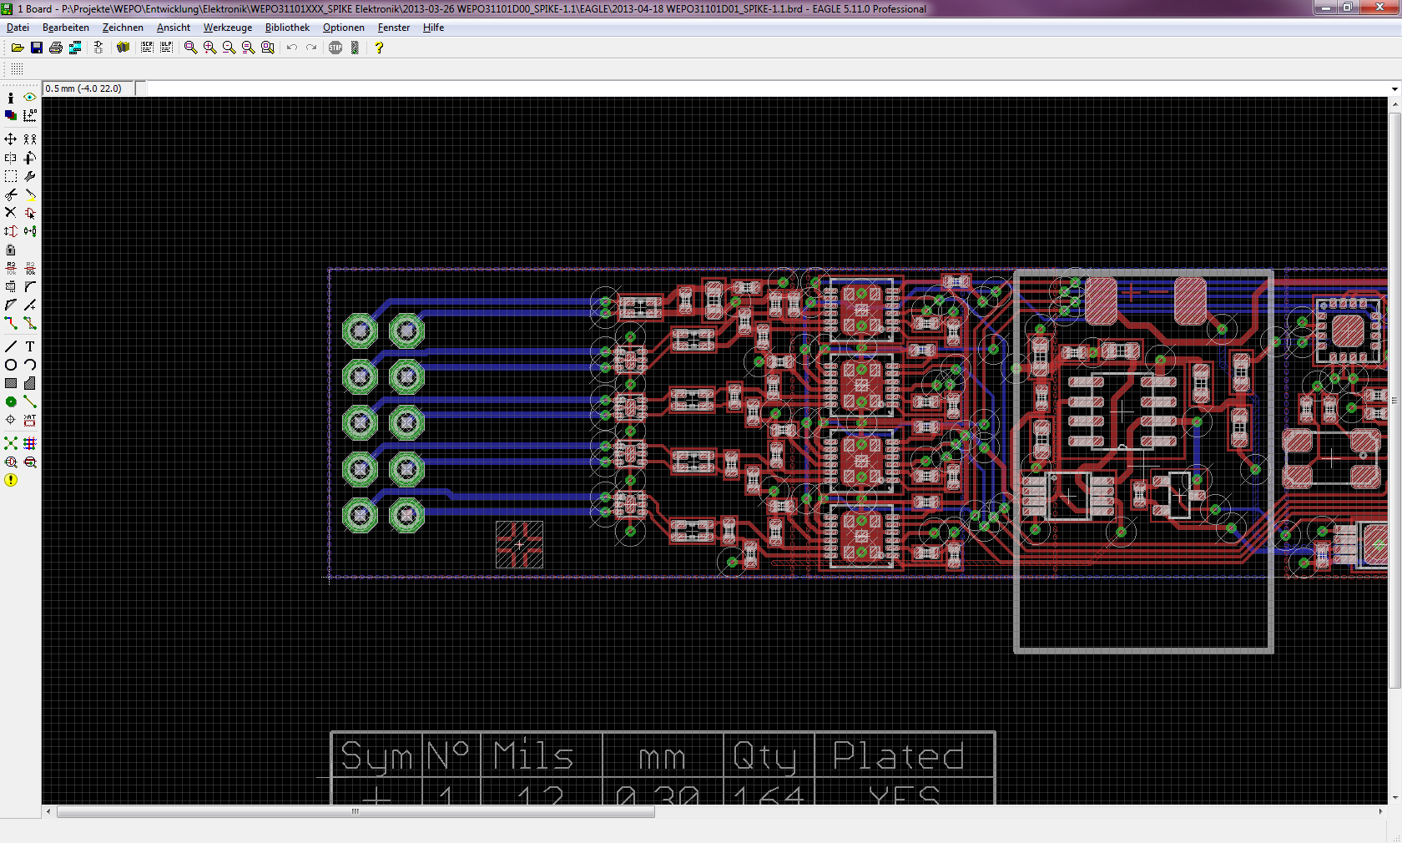

**SG_4**

**SG_2**

**SG_1**

**SG_2**

* 1. (Configuration bridge amplifier)
* OSR: 128
* NELCONV: 2
* GAIN: 1010,583
* OSF: 500 kHz
* Externe Referenz
  1. (Auto-Offset Adjustment)

- Adjust offset as much as possible with the existing hardware  
- Offset the remaining no longer have the hardware can be calibrated save as a value and the measured value always preview (disadvantage: displacement of the measuring range)  
- Offset adjustment is triggered by a command from table (CMD: OFFSET 0x31)  
- Green LED lights when the offset compensation  
- For the offset adjustment values are averaged over 100

Procedure:  
  
1. the current measured value, respectively (mean form, 100 values)  
2. if not correct in some interval up or down  
3. Repeat 1 and 2 so long to offset adjusted (hardware offset)  
4. Remaining Offset Offset as a software store (average100 values)  
5. Define New offset values in the EEPROM

1. Zeitstempel Generierung Timestamp generation
   1. Old version: RTC

Timestamp is generated on Reed  
Problem: too vague as derived from the Real Time Clock  
(32.678 kHz -> 30.518 microseconds smallest increment)  
Transmission time of radio packet is included in the calculation

🡪 no exact time or FFT analysis is possible

* 1. (New version: packet counter)

**Timestamp is calculated  
Each value has exactly the same time interval (625 microseconds)  
Each package has 7 readings (total of 4375 microseconds)  
About the packet counter the time can be assigned  
Regardless transmission time  
Equidistant measurements**

**🡪 FFT possible if a corresponding hardware low-pass filter is used to prevent aliasing**

Special features:  
If the reed rebooted and connected a SPIKE its packet counter starts not at zero, the time stamp does not start even at zero  
If another SPIKE about Reed read the packet counter is smaller than the packet counters of the previous one, so an overflow of the packet counter is detected and 286720000 microseconds (= 65536 *625μs * 7 ) plus the new packet counter for old time stamp added to it.  
The time stamp is transmitted at a "3" and "s" is reset to zero

1. Power Management
   1. Batteriespannung (battery voltage)

The measurement of the battery voltage is checked after each transmission of a data packet (state "Send") and after you wake up the microcontroller (state "Wake Up")

setting ADC

* 1,1 V Reference Voltage (intern)
* Free Running Mode
* Prescaler: 32
* Auto Trigger Enable
* 8 Bit resolution (left adjusted, only ADCH)
  + 1. circuit

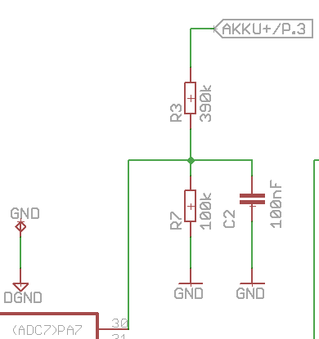

Abbildung : Spannungsteiler vor ADC Figure 1: ADC voltage divider ago

Calculating the voltage on the Reed::

* 1. (System shutdown)

The measurement of signals of the bridges depending on the battery voltage has revealed that the system when falling below a certain threshold no valid values indicating more (see Development Documentation "verification of the improvements by SPIKE 1.1" Section 3.2.13). Therefore, the following was determined:  
  
Shutdown in the event of a battery voltage <3.5V  
As long as the battery voltage <3.52 V  
◊ stay in "Sleep" despite interrupt from the acceleration sensor

* 1. Stromaufnahme im Akkubetrieb Power consumption in battery mode

The average power consumption was measured directly after the battery with a multimeter.

* Sleep-Mode: 1,55 mA
* Active mode (no bridges): 31,8 mA
  1. Battery life test

In one experiment, the run time was examined with a fully charged battery. Here, all consumers have been (even the 4 bridges) is connected and the timeout is disabled.



figure 2: Run-time of the battery with a fully charged battery

In this experiment, a term of approximately 11.8 h was achieved. This term refers only to a continuous measurement. Located between the measurements of the SPIKE in longer standby phases, so the above measured runtime is not reached.

* 1. Display of battery status on the Reed

With the measured voltage curve of section 5.4 of the battery state of charge can be determined. Since in the "active mode", a constant current flows there can be calculated from the measured voltage the state of charge.  
  
This state of charge is output to the reed on the LEDs for the battery voltage. To this end, the thresholds were redefined as follows:

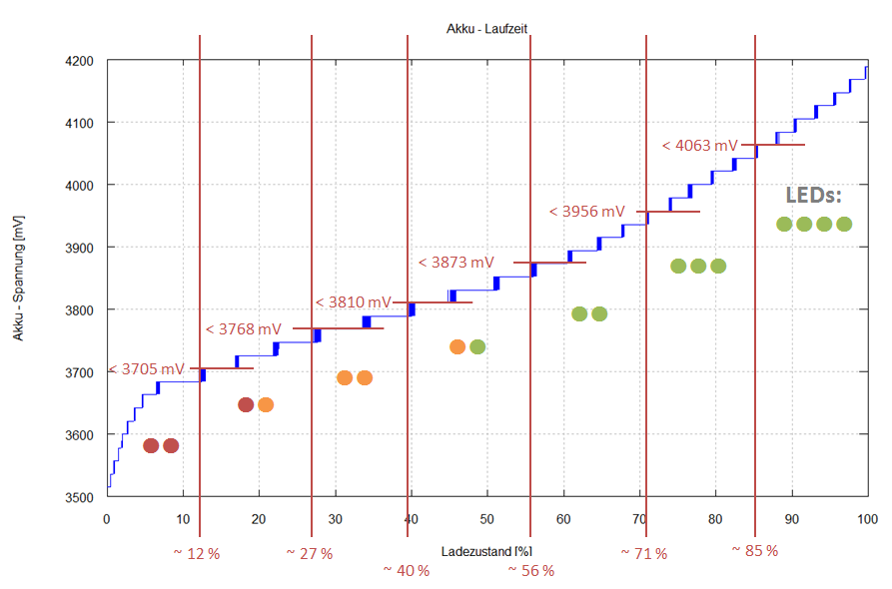

Abbildung 3: Threshold values for indicating the charge status of the battery at Reed (LEDs)

Battery charging time  
To charge a completely discharged battery is needed approximately 2 hours and 15 minutes..

1. Ablauf Firmware expiration firmware
   1. state machine

The main program is implemented as a state machine. This ensures that only one state can occur at the same time and the change of state is precisely defined.

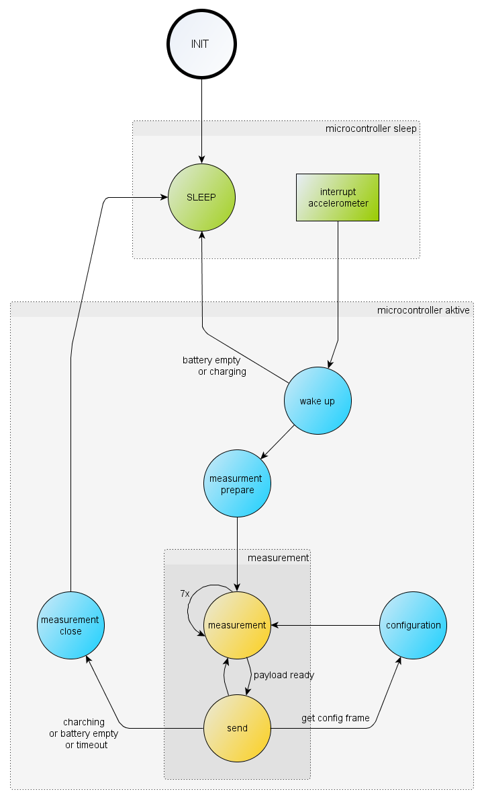

Figure 4: State machine of the main routine Zustände

The states are additionally divided into two categories. On the one hand there are states in which the microcontroller in sleep mode is on the other states in which the microcontroller is active and executing various tasks. Depending on the category has a different power consumption required.

* + 1. Init

The state "INIT" is right after supplying the board with voltage and called in later program may cease. In this state, the microcontroller and sensors are initialized. Furthermore, are still performed the following actions:  
  
Stop timer (1600 Hz)  
Bridge amplifier in sleep mode and bridge restoration from  
Temperature sensor in sleep mode  
Analog-to-digital converter from  
Radio chip in sleep mode  
  
The next state is "SLEEP“

* + 1. Sleep

In the "SLEEP", the microcontroller enters power save their "idle" mode. Prior to that, the following settings are still made:  
  
Clock Prescaler 8 set (~ 1.25 MHz)  
All modules except analog comparator is turned off  
Interrupt for analog comparator is activated by the microcontroller to wake again  
Microcontroller mode "Idle" translated  
  
If an interrupt is triggered, the next state "wake up" is called.

.

* + 1. Interrupt accelerometer: acceleration above threshold

Is the acceleration of the analog acceleration sensor above the defined threshold value and the controller is in "SLEEP", so an interrupt is triggered and aroused the controller from the "SLEEP" state. **The threshold is fixed by an external voltage divider and is about 2 g.**

In the interrupt routine, the acceleration sensor interrupt is disabled to avoid another trigger (ringing of the acceleration sensor, or continuous acceleration when rotate the spikes).  
.

The analog comparator remains to be reset to the time-out during rotation of the spikes..

* + 1. Wake up

In the state "wake up" the microcontroller interrupt from an analog switches when comparator is triggered.

First, it is checked whether the SPIKE is CHARGING. If this is the case, then state is changed back to the "SLEEP"..

When the battery charge status is not checked against the voltage. Should this be empty, that state is also re-entered into the "SLEEP".  
.

If neither charged nor the battery is empty so the clock prescaler is reset to 1 (10 MHz) and it will be changed to the state "measurement prepare"..

* + 1. Measurement prepare

The condition "measurement prepare" is called before the actual measurement. Here, all sensors and components are prepared for the measurement. Generally, the following actions occur:  
  
DS620 initialize (after changing the Power Save tab TWI should be re initialized)  
Enable bridge amplifier and provide bridges with voltage  
Timeout timer and time slot number reset  
Start timer (1600 Hz)  
  
Then, immediately changed to status "measurement"..

* + 1. Measurement

As long as the microcontroller is in the "measurement" is measured continuously once the timer triggers an interrupt.  
  
The 4 bridges are read at each interrupt. Before reading will be sent to the bridge converter to start a new measurement, a request command. As long as the request is sent and the bridge amplifier will read the green LED lights up. After it is turned off again.  
  
After 200 ms once, the temperature sensor is interrogated. Care is taken that the temperature sensor is read only if the time slot number 3 is reached to avoid a collision with the sending of the data.  
  
Besides, it is checked whether an acceleration above the threshold exists where necessary the timeout timer reset.  
  
Seven data packets reached, they will be combined into one package and sent. Sending happened in the "send" in the Received after the seven data packets is changed.  
.

* + 1. Send

In the "send" the previously prepared data packet is sent. After successfully sending the following actions still to be implemented, they are executed by measuring not to interrupt intentionally only in the "Send".  
  
Received data packet? ◊ if so change to the state "config"  
Charging the battery? ◊ if so change in condition "measurement close"  
Timeout reached? ◊ if so changing to the "measurement close"  
Battery empty? ◊ if so changing to the "measurement close"  
Send to quit? ◊ if so changing to the "measurement close"  
  
If none of the above cases occur, then changes back to the status "measurement".

* + 1. Config

In the "Config" the received commands from the REED be edited. Meanwhile, no measurement is possible. All realize commands can be found in section 7.2.  
  
After successful command processing is changed to status "measurement".

**5.1.9 Measurement close**

The state "Measurement close" is called when the measurement is to be terminated. In this case, all the sensors are no longer needed are put into sleep mode and prepared the microcontroller to the sleep state.

In summary, the following actions are performed:  
stop timer  
Switch off the bridge amplifier in standby and supply of bridges  
Temperature sensor in Stand By  
off ADC  
Radio chip in Stand By  
  
The next state is the state "Sleep".“.

1. Schnittstelle Tischgerät – Flex Interface table device - Flex
   1. Vorgesehene Befehle auf der Flex Intended commands on the Flex

These commands are provided for the development phase but the product version not all enabled (see Section 7.2).  
).

|  |  |  |
| --- | --- | --- |
| Wert | Name | descriptin |
| 0x00 | REQ_STREAM | no Funktion (full config mode) |
| 0x04 | REQ_CFG | no Funktion (full config mode) |
| 0x0F | STOP_STREAM | Set Spike in Sleep-Mode |
| 0x10 | REQ_STREAM | configurationsmodus leave |
| 0x11 | READ_EEPROM | reads a byte from EEPROM (full config mode) |
| 0x12 | WRITE_EEPROM | writes a byte to EEPROM (full config mode) |
| 0x13 | WRITE_ZMD_CFG | writes configuration for ZMD (full config mode) |
| 0x14 | READ_ZMD_CFG | CFG reads configuration of the ZMD (full config mode) |
| 0x15 | READ_VERSION | Version read |
| 0x16 | SET_TIMEOUT | Set Timeout in Seconden (max 300secs) |
| 0x17 | SET_DATARATE | Sets readout rate (350 Hz - 3000 Hz) (full config mode) |
| 0x20 | C_RADIO_CH | Changes the radio channel |
| 0x21 | C_DATARATE_MODE | Changes modulation of the radio chip and thus the transfer speed (full config mode) |
| 0x22 | NEW_SRC_ADDRESS | Sets new source address (full config mode) |
| 0x23 | NEW_DEST_ADDRESS | Sets new destination address (full config mode) |
| 0x24 | NEW_PANID | Set new PAN ID (full config mode) |
| 0x25 | NEW_TX_PWR | transmission power of the radio chips change (full config mode) |
| 0x30 | READ_TEMPERATURE | Reads the current value of the temperature sensor |
| 0x31 | OFFSET | Offset adjustment of bridges |
| 0x32 | WRITE_CLAIB_VALUES | Saves calibrated value in EEPROM |
| 0x33 | READ_CALIB_VALUES | Read calibrated value |

Rot: commands only during development phase - have not been tested for function!

Grün: Commands for product

* 1. Realisierte Befehle realized commands

Only the following commands are available:

* + 1. STOP_STREAM (0x0F)

Send stops and SPIKE go into "sleep" state..

* + 1. REQ_STREAM (0x10)

Sending the value is continued..

* + 1. READ_VERSION (0x15)

The version of the hardware, software and serial number will be issued.

* + 1. SET_TIMEOUT (0x16)

This command sets the timeout can be set in seconds. It is only a maximum timeout of 300s possible. If 0s passed as a parameter so is the SPIKE in continuous state and can send only with command "STOP_STREAM" be stopped..

* + 1. C_RADIO_CH (0x20)

Changes the radio channel on SPIKE. Only channels between (11 to 26) are possible.

* + 1. READ_TEMPERATURE (0x30)

Returns the current value of the temperature sensor..

* + 1. OFFSET (0x31)

Performs an offset adjustment of all bridges. May take a few seconds depending on the mood. During the offset adjustment, the green LED lights up.

* + 1. WRITE_CLIB_VALUE (0x32)

Saves new Kalibierwerte for LabVIEW..

* + 1. READ_CALIB_VALUE (0x33)

Returns the Kalibierwerte for LabVIEW.

* 1. Verwendete Befehle LabVIEW Commands used LabVIEW

LabVIEW LabVIEW uses the following commands::

“0” nur REED

“3” nur REED

“z” Flex (0x31)

“l” Flex (0x33)

* 1. Additional commands only for calibration

These commands are additionally used during calibration:

“w” Flex (0x32)

“m” nur REED

1. State of the LED

State Colour

off off

Stand By off

Measure green

charging red

1. Measurements with the test SPIKE  
   1. Battery life measurement

On a fully charged battery SPIKE was so long operated in the continuous measurement mode until the battery is empty.

* + 1. battery voltage



Abbildung 5: battery voltage as a function of maturity

* 1. Signal of the strain sensor (time)



Abbildung 6: Digital values of the extensometer in pendency of the term

In the last 30 minutes notice that the values of the bridges drift. This is due to the decreasing battery voltage, and means that the threshold for switching-off shall be set earlier.  
.



Abbildung 7: drift of the values of the extensometer dwindling supply voltage

* 1. Signal of the strain transducer (frequency)

Considering detect the amplitude spectrum of the signal of the bridges so are three frequencies. Since the SPIKE was all about measurement alone there are interfering frequencies. These spurious frequencies occur at 228.57 Hz, 457.14 Hz and 685.71 Hz.  
.

With a sampling rate of 1600 Hz 7 reading packets will be sent to this awaited. This results in a frequency for sending::

$$\frac{1600 Hz}{7}=228,5714 Hz$$

This corresponds exactly to the disturbance frequency and the other two interfering frequencies are multiples thereof.  
  
At the bridge 4, these spurious frequencies are most clearly seen on the bridge 1 practically nonexistent..



Abbildung 8: Normalized amplitude spectrum of the 4th bridge with interference frequencies



Abbildung 9: Normalized amplitude spectrum of the 2nd bridge with interference frequencies



Abbildung 10: Normalized amplitude spectrum of the 3rd bridge with interference frequencies



Abbildung 11: Normalized amplitude spectrum of the1st bridge with interference frequencies



Abbildung 12: These spurious frequencies are clearly visible even in the time signal

These measurements were compared with the test board. At the trial board itself instead of a DMS bridge simulator. This bridge simulator the noise frequencies can not be identified..



Abbildung 13: Amplitude spectrum rigid test board with bridge simulator



Abbildung 14: Time Signal rigid test board with bridge simulator

This means that probably the DMS or the signal line need to be better shielded to prevent the coupling of the interference signal. Structure change?

M Possible interference signal interrupt line from the radio chip to the microcontroller

<Oszibild>

* + 1. temperature curve



Abbildung : temperature curve

1. Measures against the 228 Hz disturbance
   1. Output situation

As described in Section 9.3 can be seen in the signal of a 228 Hz interference bridges. This can be seen in an FFT analysis clearly in the noise.



Abbildung :

* 1. Removing the sleeve

The removal of the sleeve has been significantly reduced this effect. In this case, the distance between the electronic-Flex has increased to the contact-Flex and the DMS.



Abbildung :

* 1. Ferrite replaced by resistance

This replaced the ferrite R61 in the data line (interrupt radio module) through a 27 ohm resistor has been no noticeable improvement. Here, the sleeve is draufgesetzt not yet returned.



Abbildung :

* 1. Shielding with aluminum foil

Only the screens of the DMS and the contact-Flex brings a better result. For this measurement, the sleeve was installed again.



Abbildung :

1. New cut-off threshold of the system

After the battery life measurement in Section 9.1, the system must be turned off before a drift of the bridge signal (see Figure 7) to prevent.  
  
The new switch-off is now at 3.6 V. On the threshold values to show the battery status (see Figure 3) has not been modified..

1. Function test desktop device

Power LED (LED1) lights blue when power is supplied with PC  
Table device is detected as a USB device  
Connection via COM interface can be made

As long as no SPIKE received the STATUS LED (D4) red  
  
Commands in the terminal:  
"Spacebar" - menu  
"X" - displays current tasks  
"C" - shows configuration of the radio module to  
"ESC" - back to menu

Taster

Kein Empfang 🡪 Drücken des Tasters löst Sendersuche aus

Empfang 🡪 Drücken des Tasters löst Offsetabgleich aus

button  
No reception ◊ Press the button triggers tuning of  
Receiving ◊ Press the button triggers offset compensation from

1. Funktionstest Firmware Flex
   1. Commands from table device

|  |  |
| --- | --- |
| **command** | **OK ?** |
| Timeout mindestens 1s, Timeout maximal 300s (0x16) | ✓ |
| Timeout 0s 🡪 immer an (0x16) | ✓ |
| Timeout > 300 s 🡪 Fehler (0x16) | ✓ |
| Version read (0x15) | ✓ |
| Send stop (0x0F) | ✓ |
| „Request stream“ (0x10) | ✓ |
| Change channel from 11 bis 26 (0x20) | ✓ |
| Change channel, invalid channel 🡪 Fehler (0x20) | ✓ |
| Temperatur a Reading (0x30) | ✓ |
| Offset compensation („z“ oder Taste) | ✓ |
| read calibrate value („l“) | ✓ |
| write calibrate value („w“) | ✓ |

* 1. offset adjustment

|  |  |
| --- | --- |
| **Function** | **OK ?** |
| Offset ist positiv 🡪 adjustment is possible | ✓ |
| Offset is positive and possible outside the measurement range ◊ balance | ✓ |
| Offset is negative and possible outside the measurement range ◊ balance | ✓ |
| Offset values are not saved after switch off at / by disconnecting the power supply | ✓ |

* 1. Standby

|  |  |
| --- | --- |
| **Function / state** | **OK ?** |
| Standby after turn | ✓ |
| During acceleration above the threshold measuring ⎫ | ✓ |
| After the timeout expires change in standby | ✓ |
| Standby power consumption as in chapter x measured | ✓ |
| Current consumption measuring x measured as described in Chapter | ✓ |

* 1. Charging

|  |  |
| --- | --- |
| **Function** | **OK ?** |
| Once Spike in charger no longer possible measurement and LED lights purple | ✓ |
| charging Complete LED lights up blue; no measurement possible | ✓ |
| Once SPIKE is removed from the charging cradle again is a measurement possible | ✓ |

* 1. Control/check the battery voltage

|  |  |
| --- | --- |
| **Function** | **OK ?** |
| Measuring the battery voltage greater than ± 2% deviation | ✓ |
| Shutting down the system after the threshold below as defined in Chapter X, no measurement possible | ✓ |
| Battery voltage above threshold, measurement possible | ✓ |

* 1. Timing

|  |  |
| --- | --- |
| **Function** | **OK ?** |
| 1600 Hz sampling rate with a maximum of 1% deviation | ✓ |